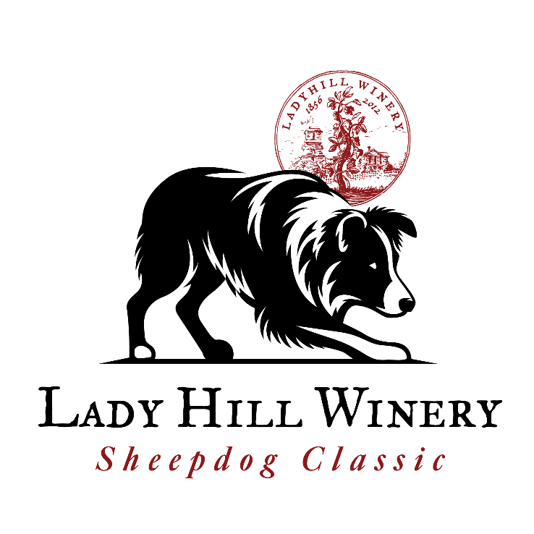
A wonderful NEW sheepdog trial in the heart of Oregon’s Willamette Valley. Held at the outstanding Lady Hill Winery in full view of the beautiful tasting room and a gently sloping hillside for spectators.
The open course consists of a 250 yard uphill outrun where the dog will be completely out of sight at the lift. There will be a 600 yard drive on the side of the hill followed by a shed, pen and single.
Camping for handlers is available on site and there will be a handlers dinner on Saturday night. The meal is provided by the winery free of charge but you will need to buy your beer (brewed specially for the event) and wine on site. Due to licensing restrictions no outside alcohol is allowed on site (in your trailer is fine).
The Winery address is 8400 Champoeg Rd NE. Saint Paul OR 97137. Detailed directions for handlers will be provided with running orders.

Lady Hill Sheepdog Classic
Lady Hill Winery, Champoeg OR June 13-15, 2025
Classes: Open, Nursery, Pro-novice, Brace
Judge: Diane Deal, Idaho
Sheep: Commercial Crossbred wool sheep (replacement value $250)
Entry Fees PER RUN: Open -- $80 PN -- $45, Nursery -- $48, Brace -- $20
Friday: Nursery (2 runs available), Pro-Novice (1 run), Brace (limited to 10 teams)
Saturday & Sunday: Open (1 run per day)
Handlers Meeting: 7:45 am each day
Trail Rules & Sanctioning: USBCHA
Awards: Open: Prize money to top 10% awards for top 5 dogs.
PN: Prize money to top 10% awards for top 3 dogs (top 2 if less than 20 dogs)
Nursery: Awards for top 2 dogs (top 1 if less than 8 dogs)
Brace: Awards for first & second place, Money to third place.
Entry submission: Entries must be postmarked between April 1- April 12. No refunds after May 15
Mail entries to: Ian Caldicott, Lady Hill Classic, 39562 Hwy 226 Scio OR 97374
Checks made to: Wolston Farm
Questions: Call: 541-971-0372 or e-mail: imc@wolston.com
May be limited to 2 dogs per person per class, if entering more please put extra dogs on separate checks.
Dogs Name | Age | Class | # of Runs | Fees
 |  |  | Total entry fees
Handler/Owner Name: ________________________________
Address: _____________________________________________________
Phone: _________________________ e-mail: ________________________________
Lady Hill Sheepdog Classic Champion Trophy will be presented at the end of the trial on Sunday. Winner MUST be present to receive the award.
Liability Waiver
I hereby forever give up my right to bring any claims including for personal injuries, death, disease or property losses, or any other loss, including but not limited to claims of negligence against the property owners, trial hosts, any family member or employee of the property owners, USBCHA, or the judge, any sponsor, or volunteer and give up any claim I may have to seek damages, whether known or unknown, foreseen or unforeseen. I also agree to pay, at time of occurrence, the shepherd’s value ($250) for any sheep damaged by my dog or any dog under my supervision. The trial hosts have sole responsibility to determine the cause of sheep loss or injury.
Participant signature: ___________________________________ Date signed: ____________________

